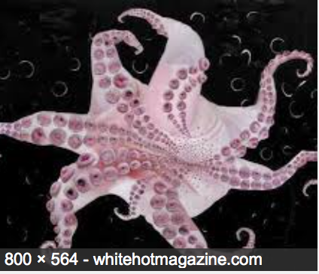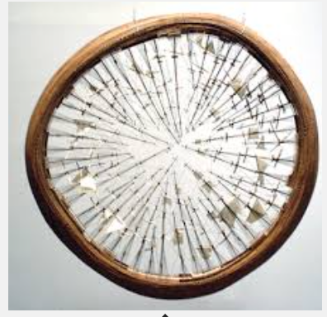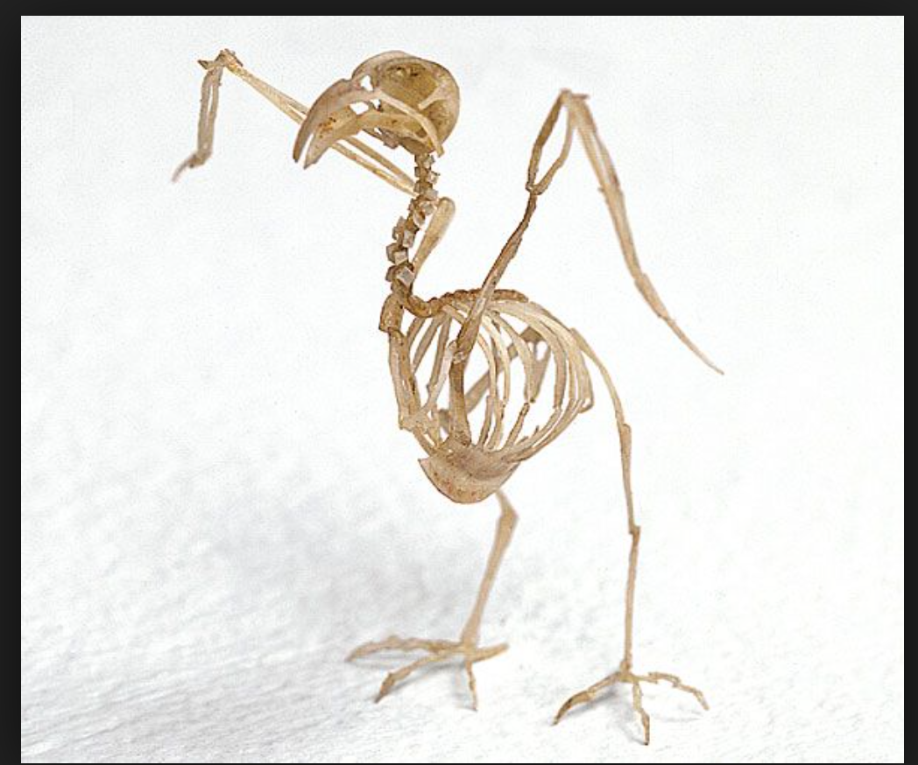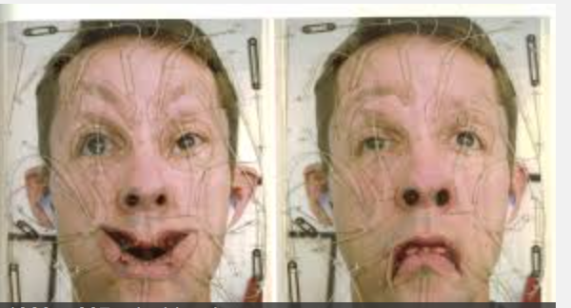

Date:

Media:

Description:

Octopus

Date:

Media:

Description:

# Tim Hawkinson

Starting on September 1 until September 30th, Tim Hawkinson will be showing some of his most famous work The Getty Museum in Los Angeles. You will be taking a museum tip to view his work. Bring this brochure with you on your trip. There will be a photo of each of his pieces of work that I want you to write a brief description of in the space provided.

#### At the Getty

#### With Mrs. Knego

## Mobius Ship

Which of Tim Hawkinson’s pieces of work interested you the most, and why?

How would you describe his work as a whole collection of pieces?

Did you enjoy your tip the Getty? Was there another artist that you were interested in more?

Date:

Media:

Description:

# The Emoter

## Q&A